Asia-China-Mirrors- Western Han dynasty (206 B.C.E.–8 C.E.)-

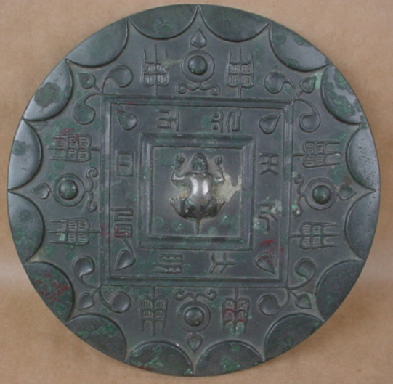
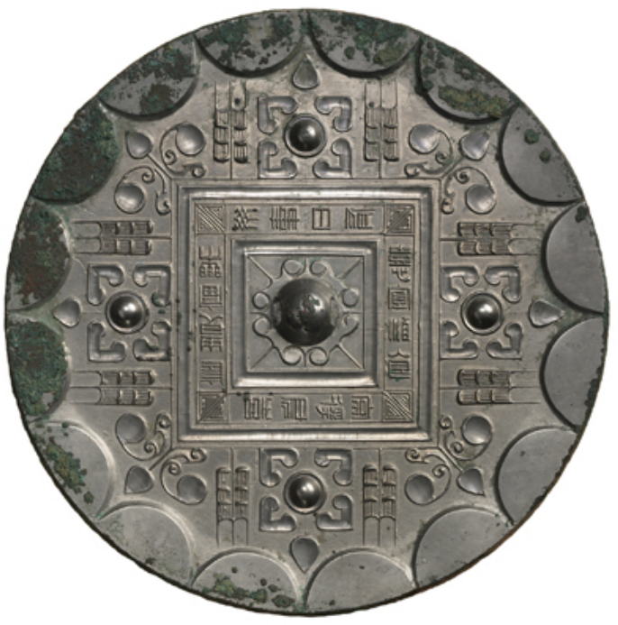
The earliest inscribed mirror in the Cotsen collection is from the Western Han dynasty (206 B.C.E.–8 C.E.). Within a design that embodies the cosmic principles of space, time, heaven, and earth, the inscription reads:

May you enjoy noble status and
blessings for a long time;
May you have pleasure without incident;
May you have delight every day;
May you have plentiful wine and food;
And may you regularly obtain lordly delights.
Mirror with Quatrefoil, Grass Motifs, Stars, and Linked Arc
Western Han dynasty (206 B.C.E.–8 C.E.)

